CST8276 – Advanced Database Topics: Lab 2 - Understanding Oracle’s architecture and key parameter files

Student Name: Jake Elliott
Student ID: 040732505
Student email: elli0449@algonquinlive.com

Purpose: This lab reinforces your classroom discussions concerning Oracle architecture
Requirements: Complete the required tasks and submit the required responses in the same word document renamed as lab2_fname_lname (e.g., Lab2_Doug_King) via Brightspace by the end of the lab and demonstrate your work to the lab professor.
A complete and on-time submission will earn 2 marks.

Resources: https://docs.oracle.com/cd/B28359_01/server.111/b28318/startup.htm#CNCPT1293
https://docs.oracle.com/database/121/CNCPT/startup.htm#CNCPT601
https://docs.oracle.com/cd/B28359_01/server.111/b31189/ch12042.htm
https://docs.oracle.com/cd/B28359_01/server.111/b28286/statements_6008.htm#SQLRF01308

Lab Submission tasks:
- Demo / Problem Solving: During Week 2's lab, you will be required to confirm your Oracle 19c installation is working properly.

- Concepts: Refer to the above noted resources. Copy your answers to your submission document.
  - Without using virtual tables or similar mechanisms, a database instance can be associated with 1 database(s). [How many?]
  - To start a database instance, configuration parameters must be read. This information is contained in binary format in the SPFILE (Server Parameter File) and in text format in the PFILE (Parameter File).
  - During STARTUP, the instance knows where the data files are located by reading the Control File file.
  - The main difference between a TRANSACTIONAL SHUTDOWN and an IMMEDIATE SHUTDOWN is, in a TRANSACTIONAL SHUTDOWN Transactional shutdowns complete all transactions BEFORE shutting down, whereas in an IMMEDIATE SHUTDOWN Terminates all transactions immediately without waiting for them to complete, and any uncommitted transactions are rolled back.

- Review the Startup/Shutdown Process (Write the queries and their results):
  - Logon as SYS as SYSDBA.
  - Enter SHOW PARAMETERS
    - From the SHOW PARAMETERS results, determine where the SPFILE file is located. Record this location in your lab file below.
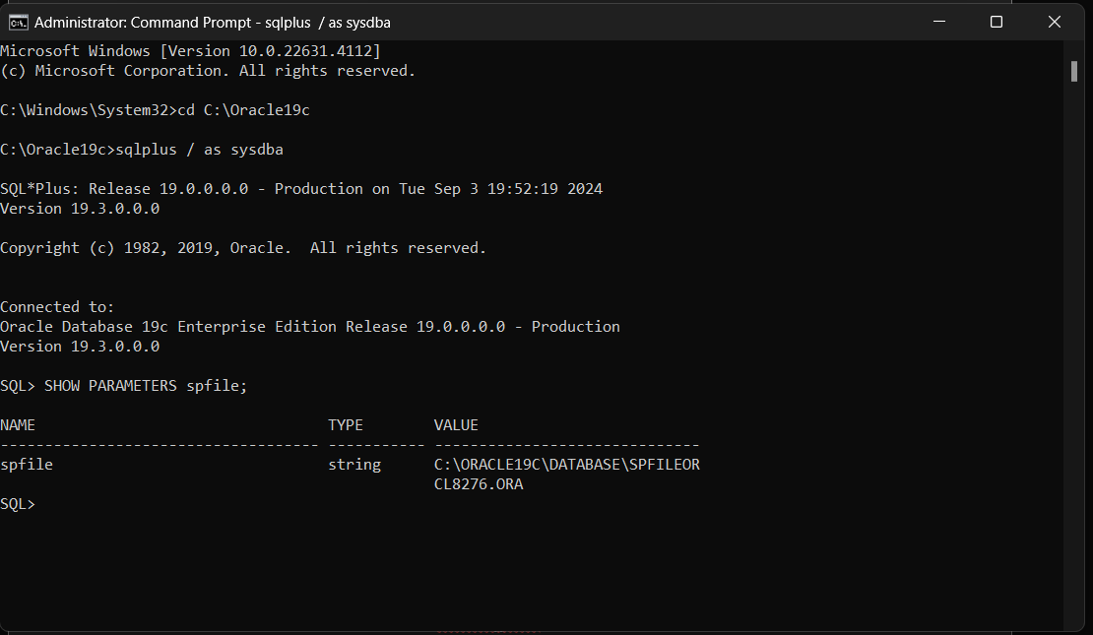
  - Create a PFILE: Enter: CREATE PFILE from SPFILE;
  - Locate and resulting PFILE and in your lab document, specify:
    - the name of the pfile (show a screenshot of the folder and file on disk)
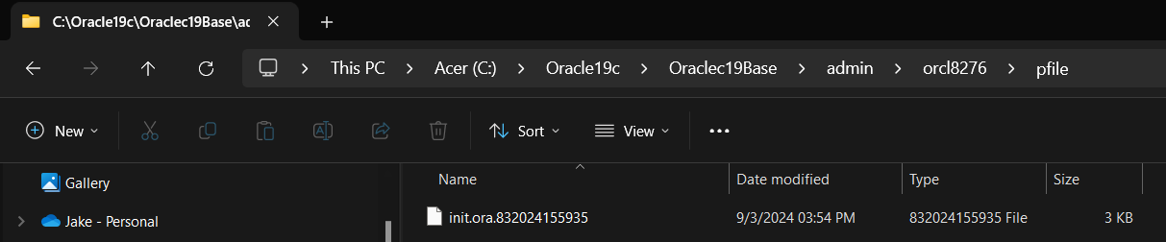
    - Open the file and determine the oracle_base name (show a screenshot of the file contents)
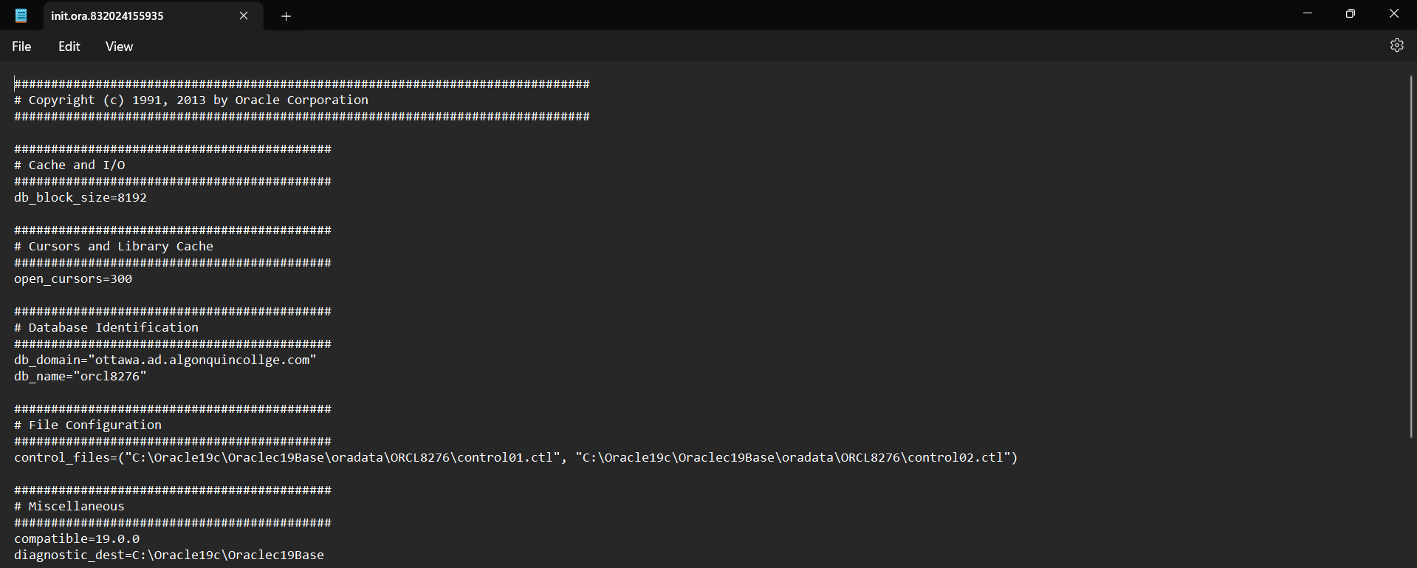
    - the location of the control_files
  - Enter: SHUTDOWN
  - Enter: STARTUP
  - Indicate, in your lab document, the sequence of objects being started.
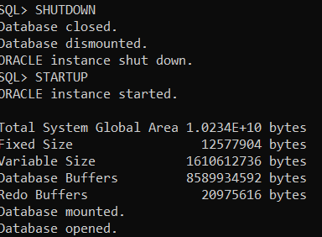
- DATA DICTIONARY: From the SQL prompt, enter DESC DICT- this command describes the structure (the columns) of the internal data dictionary.

Hint: Throughout the course, when you forget the names of special tables you can return to the dictionary and determine the name.

In your lab document answer the following questions (Write the queries and their results):
  - List the number of rows that are in this table (you may not want to select the rows as there are a lot).
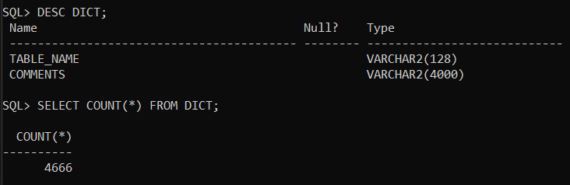
  - List the name of the view or table that describes Tablespaces: 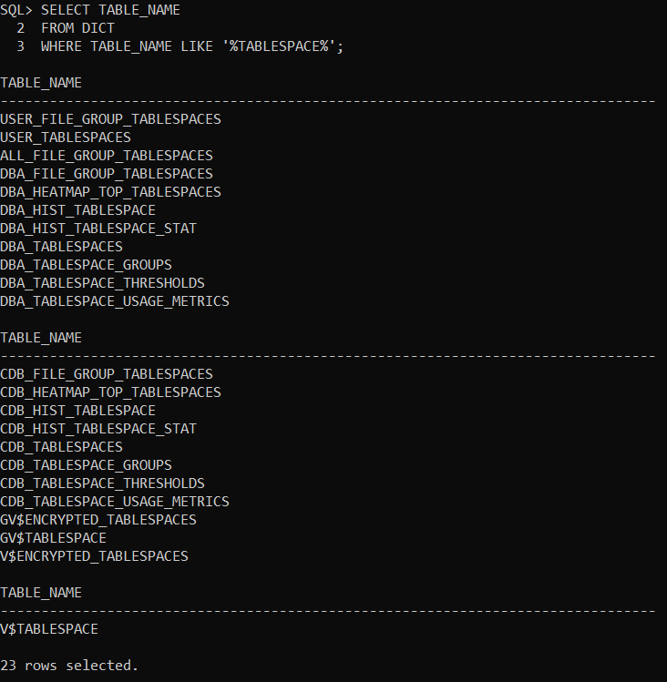
- List the name of the view or table that describes Datafiles: 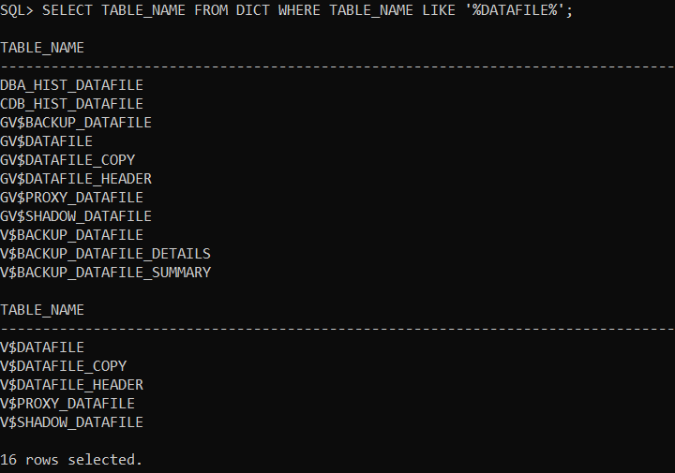
  - Write a query that joins the V_$DATAFILE and V_$TABLESPACE tables, then use the query results to answer the following questions:
    - What is the location and name of the datafile associated with the SYSTEM tablespace. C:\Oracle19c\Oraclec19Base\oradata\ORCL8276
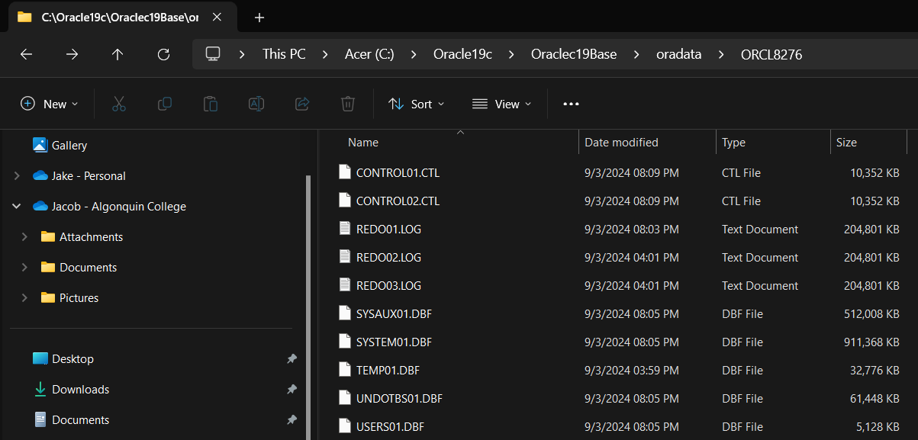

    - What is the location and name of the datafile associated with the USERS tablespace. C:\Oracle19c\Oraclec19Base\oradata\ORCL8276


You're done. Submit your lab.

